Feign is a declarative HTTP client in Java, often used to simplify making HTTP requests to external services. It's commonly used in microservices architectures, particularly with Spring Cloud. Feign allows you to define an interface and annotate it with annotations that describe the HTTP request, and it handles the rest.

**Steps**

* **Add Dependencies**: Add the necessary dependencies to your pom.xml file for Maven Already done by Seniors
* **Enable Feign Clients**: Enable Feign clients in your Spring Boot application by adding the @EnableFeignClients annotation to your main application class. Already done by Seniors

**Define the Feign Client Interface**: Create an interface and annotate it with @FeignClient. This annotation tells Spring to create a bean for this interface that will handle the HTTP requests.

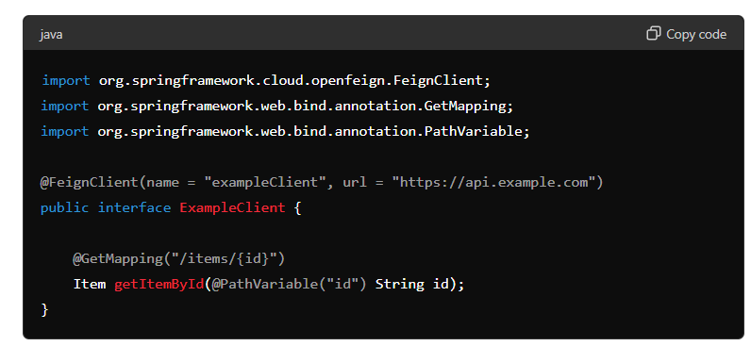

**Use the Feign Client**: Autowire the Feign client into your service and use it to make HTTP requests.

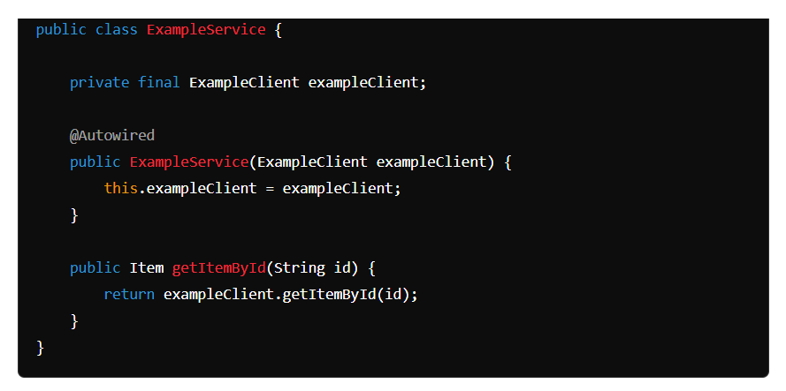

Q1. What is Feign Client?

Feign client is a declarative HTTP client in Java used to establish communication between two microservices.

Q2. What does @EnableFeignClients annotation do?

This annotation scan the class path for any interface annotated with @FeignClient annotation to create a proxy for them.

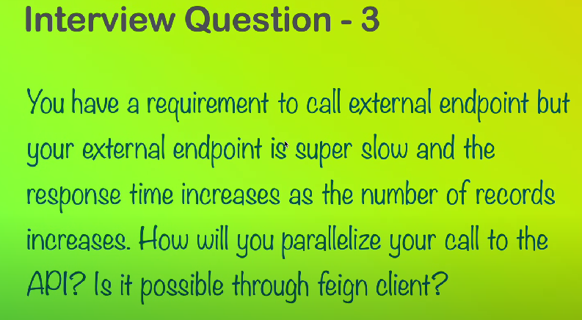

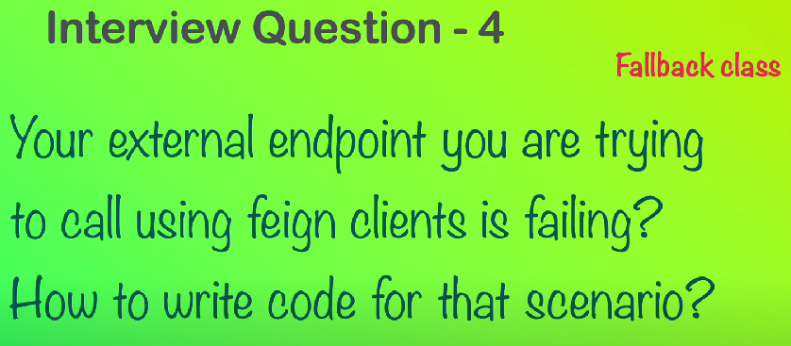

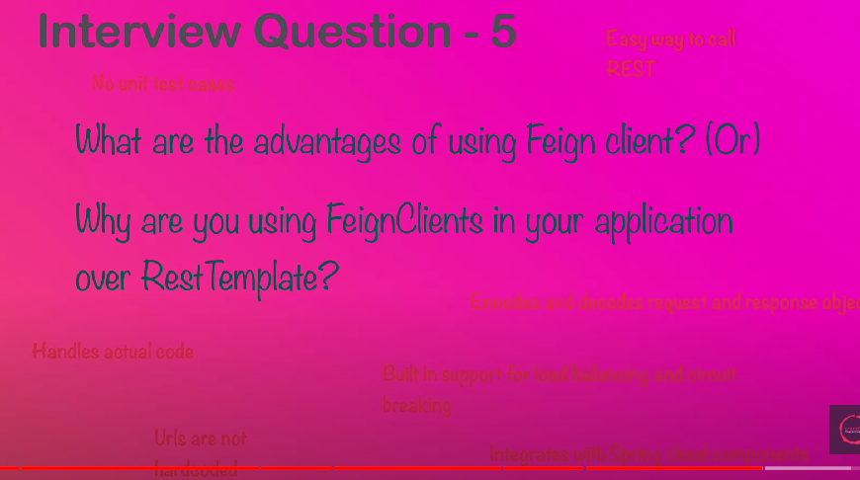

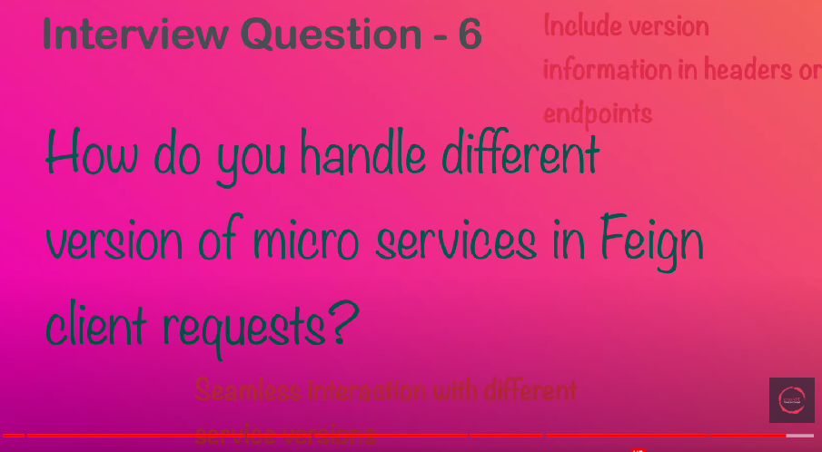

**Can you explain in detail about all the arguments of @FeignClient annotation**

**attribute:**

**name**

* **Description**: Specifies the name of the Feign client.
* **Usage**: This name is used to create a Spring bean and can also be used for logging and metrics.
* **Example**: @FeignClient(name = "myClient")

**url**

* **Description**: Specifies a fixed URL for the service that the Feign client will communicate with.
* **Usage**: Useful for testing or when the service URL is static.
* **Example**: @FeignClient(name = "myClient", url = "http://example.com")

**value**

* **Description**: An alias for name. They are interchangeable.
* **Usage**: Can be used instead of name for simplicity.

**Example**: @FeignClient(value = "myClient")

**configuration**

* **Description**: Specifies custom configuration classes for the Feign client.
* **Usage**: Used to customize aspects like encoding, decoding, error handling, etc.
* **Example**: @FeignClient(name = "myClient", configuration = MyFeignConfig.class)

**fallback**

* **Description**: Specifies a fallback class to use if the Feign client fails.
* **Usage**: The fallback class must implement the Feign client interface and provide alternative implementations for methods.
* **Example**: @FeignClient(name = "myClient", fallback = MyClientFallback.class)

**fallbackFactory**

* **Description**: Specifies a factory class to create fallback instances.
* **Usage**: Allows more control over the creation of fallback instances and can be used to log or wrap exceptions.
* **Example**: @FeignClient(name = "myClient", fallbackFactory = MyClientFallbackFactory.class)

**path**

* **Description**: Specifies a common path prefix for all requests made by the Feign client.
* **Usage**: Useful for APIs that have a common base path.
* **Example**: @FeignClient(name = "myClient", path = "/api")

**decode404**

* **Description**: Indicates whether 404 (Not Found) HTTP responses should be decoded into an empty response.
* **Usage**: When true, 404 responses are handled as empty responses rather than throwing exceptions.
* **Example**: @FeignClient(name = "myClient", decode404 = true)

**primary**

* **Description**: Indicates whether this Feign client should be marked as the primary bean in case of multiple Feign clients.
* **Usage**: Useful for autowiring when there are multiple Feign clients and one should be preferred.
* **Example**: @FeignClient(name = "myClient", primary = true)

**contextId**

* **Description**: Provides a context ID for the Feign client.
* **Usage**: Useful for distinguishing between multiple Feign clients with the same name in different contexts.
* **Example**: @FeignClient(name = "myClient", contextId = "myClientContext")

**qualifier**

* **Description**: Specifies the qualifier value for the Feign client bean.
* **Usage**: Useful for differentiating between beans of the same type.
* **Example**: @FeignClient(name = "myClient", qualifier = "myClientQualifier")